New Albany Youth Flag Football League

Maroon League Rules
  - July 2023

Our Mission
New Albany Youth Flag Football League’s (NAYFFL) mission is to teach the youth of New Albany and surrounding communities the fundamentals of flag football.
This instructional league is designed to promote good sportsmanship, teamwork, safety, balanced competition and the respect for teammates, coaches, opponents, parents, and the community.
All participants are guaranteed playing time under the league’s constitution with a great deal of emphasis placed the participant’s safety & wellbeing.

General Rules
Playing Time
It is the objective of the NAYFFL that all attempts will be made to provide EQUAL playing time for all participants. While it will not be possible to exactly provide the same minutes, each coach will make every effort for the participants to be equally represented on the field of play
Flag, Flag Belts and Balls
All players must wear the league issued, regulation flags or flag belts. The flags must hang down from both sides of the waist – on the hips. The flags may not be rolled, tied, pinned or sewn on the belt. Shirts will be tucked so as to allow flags to hang completely unobstructed. No shirts / jerseys are allowed to obstruct the flag or “flag guarding” will be called. Footballs issued by the league will be the official game ball – no exceptions
Uniform
All athletes must wear their league-issued jersey on game day. League issued shorts are recommended but not required. Only tennis shoes & rubber cleats are allowed. Winter hats will be allowed at the discretion of the official during a game – no baseball hats will be allowed under any circumstances. No jewelry or necklaces are allowed.
Game Duration
The game is divided into two halves – each lasting 25 minutes with a 5-minute halftime. The clock is a running clock and will only be stopped at the discretion of the official for injury, etc. With one minute left in the game, two more offensive plays are guaranteed. Extra points are an untimed down if a touchdown is scored on the last play of the first half or the last play of the game.
Field Dimensions
The playing field is 25 yards wide by 50 yards long
Coach QB in First Half
Coaches will play QB in the first half of each game.
Kickoffs
There are no kick-offs in flag football. Instead, the ball is placed on the 20-yard line of the offensive team. The clock will start upon placement of the ball.
Scrimmage Play
The offensive team has 25 seconds to put the ball into play after the official whistles the ball ready to play. Failure to do so may result in loss of down.

First Down
Each team will have four plays to attempt a first down. First downs will be achieved to getting to mid-field – where a new set of downs will be provided to score a touchdown. If the offensive team fails to gain a first down or fails to score a touchdown, the ball will change possession with the defensive team taking position at their own 20-yard line. A 1st down is gained (or a touchdown/2 pt. conversion is scored) when the ball carrier’s flags cross the 1st down line or goal line. Reaching just the ball over the line is not sufficient.
Rushing the Ball
The ball must be snapped from the ground to the QB at the start of every play. Direct hand-off, toss or pitch behind the line of scrimmage are all legal. Only the running backs can receive a hand-off, toss or pitch. The QB cannot take a snap and hand it back to the center – the center is only eligible for a pass beyond the line of scrimmage.
Also, spinning is allowed but players cannot leave their feet (officials’ discretion) in order to avoid a tackle. No flag guarding the hands, arms or elbows is allowed. Stiff-arming is not allowed.
Offensive Blocking
Shield Blocking / Screen Blocking is the only acceptable form of blocking allowed with no exceptions! Shield blocking is defined as a blocker impeding the defender’s line of play. The blocker may put their body between the ball carrier and the defender. The blocker’s arms may be elevated to form a “T” with fists abutting their chest, but the blocker may not extend their arms to interfere / shove the defender accordingly. Blocking below the waist is not permitted
Tackling
A tackle is made by removing one flag from the belt of any player advancing, holding or carrying the ball. At no time may a player push/bump any player out of the field of play resulting in a dead ball. If flag falls off the ball-carrier on its own, the ball-carrier is still live, and must be “tackled” by one-hand tag.
Charging/Diving
Charging and Diving are not allowed at any time. Charging is defined as running into another player to avoid being tackled, to make a tackle or to make a block. Diving will be defined as willfully diving to make a defensive or offensive play.
Pass Eligibility
All players are eligible to receive a pass, including the center. Players must have one foot in-bounds when making a catch. An incomplete pass behind the line of scrimmage is an incomplete pass and not a fumble. The down will be lost, and the ball spotted at original line of scrimmage.
Scoring
A touchdown is equal to 6 points. Extra points – worth 2 additional points – will be attempted after each touchdown.
Extra Points
After scoring a touchdown in both first half and the second half, the scoring team must attempt a two-point conversion.
- The ball will be placed at the 2-yard line and a play will be run (and defended).
- The play can be a forward pass only.
- Defensive penalties during the play will result in a successful attempt. Offensive penalties will result in a failed attempt.
- Defensive interceptions simply result in a failed attempt and cannot be “advanced.”
In addition, two-point conversions at the end of the first half and the end of the game are untimed downs. If a team scores on the last play of the first half or the last play of the game, they can and must attempt a two-point conversion

Dead Ball
The ball will be declared “dead” when:
  - Either flag on the ball carrier is pulled,
  - The ball is fumbled and/or hits the ground.
  - The center does not get the ball to the QB.
  - The ball carrier’s knee hits the ground
  - The ball carrier steps out of bounds.
  - An interception is thrown.
  - A touchdown is scored
Punts
There are no punts in flag football. All teams will have for downs to score either a first down and / or touchdown (as outlined above).
Penalties
The following penalties will be assessed for the infractions defined above:
- Charging (offensive and defensive) - five-yard penalty from the spot of the foul
- Diving – called at discretion of referee, and starts with a warning to player and coach, will then result in 5-yard penalty from spot.
- Illegal/incorrect offensive blocking - five-yard penalty from the spot of the foul without a loss of down
- If an offensive player leaves their feet in an attempt to avoid a tackle - play will be blown dead at the spot of the foul
- Flag guarding - the play being blown dead at the spot of the foul
- Blitzing/offsides will result in a five-yard penalty from the spot of the foul without a loss of down.
- Trick play calling (as defined by the respective league) will result in loss of down and the ball being placed back on the previous spot
- Failure to rotate will result in the loss of the subsequent down – if the current down is 4^{th,} then the penalty will result in a turnover.
- Unsportsmanlike Conduct – called at the discretion of the referee and may result in loss of down or expulsion of the player or coach.
Mercy Rule
The Mercy Rule will be enforced in the second half only. A team must use one less player when/if they are winning by 18 or more points. The winning team will return to “full strength” once the point differential shrinks to less than 18.
Example – A team scores its third touchdown to make the score 18 – 0. They must use one less player on the 2-point conversion try and the ensuing defensive series. This rule still applies to the ensuing offensive series, provided the team is still up by 18 or more points.
OT Rules
There is no overtime during the regular season. These games can end in a tie. During the play-offs, however, games will be allowed to go into overtime if the score is tied at the end of regulation. College football overtime rules will apply. Each OT session will have alternating possessions at the 20-yard line. Each team has four downs to get the ball into the end zone, followed by extra point attempt. Game over when one team has scored more points at the end of that OT session.

Maroon Specific Rules
Purpose
The Maroon League is an instructional and recreational league. For most of the players this is their first or second year playing organized football. The #1 objective of this league is to instruct and prepare the players in the game of football. All coaching efforts should be to instruct and include – therefore all rules should be interpreted accordingly.
Equal “Touches”
Teams must distribute offensive opportunities across the entire team. Once a player has had a touch – they should rotate out. A snap taken at QB can constitute as a touch but does not require that player to exit the game.
Touches should be distributed linearly, meaning no player has should have 2 touches before any one player has 1 touch. Further, no player should get their 3rd touch before each player has 2 touches, etc. An assistant coach should keep track to ensure equity.
Each half starts the process over – meaning you do not need to carry from the first half.
Every player will have an opportunity at QB multiple times during the season.

Number of Players
All teams must play 5 players on defense and 5 players on offense in the first half (Coach QB) and
all teams must play 5 players on defense and 6 players on offense (5 plus youth QB) in the second half – unless the Mercy rule is in effect (see above). A team must be able to field an entire starting line-up to begin the game. If a team will have less than 6 players at game time, they can “call up” a number of players from Mini League. The number of called-up players plus the number of players present from the original roster will not exceed 6 players.
Coaches on the Field of Play
One offensive coach and one defensive coach will be permitted on the field of play at any given time during games. Coaches should not directly impact play on the field. Coaches must make every effort to avoid interfering with active play during a game. If a play is impacted or obstructed by a defensive coach – the play will be replayed. Referees have discretion to award loss of down or eject coaches for infractions.
At no time, are additional coaches permitted on the field of play during a game.
Time Outs
There are no time outs in Maroon League.
Offensive Alignment
All teams will be required to play with 6 players. Any and each formation must include a Center and a QB. Each snap must be from the ground directly to the QB. Snaps must be taken under center – no shotgun snaps. Any formation requires at least one player (running back) in the backfield (behind the QB and between the “tackles”) and at least 3 players on the line (Center + 2 receivers) with at least one receiver on each side of the field (no Trips allowed). The receivers must be outside of the “tackles”. Running backs may be in the “I” formation or in the “split back” formation.
Allowable Formations
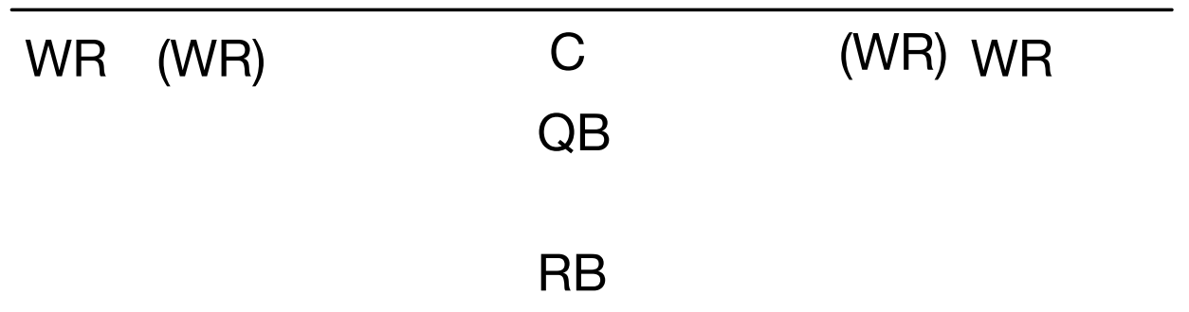

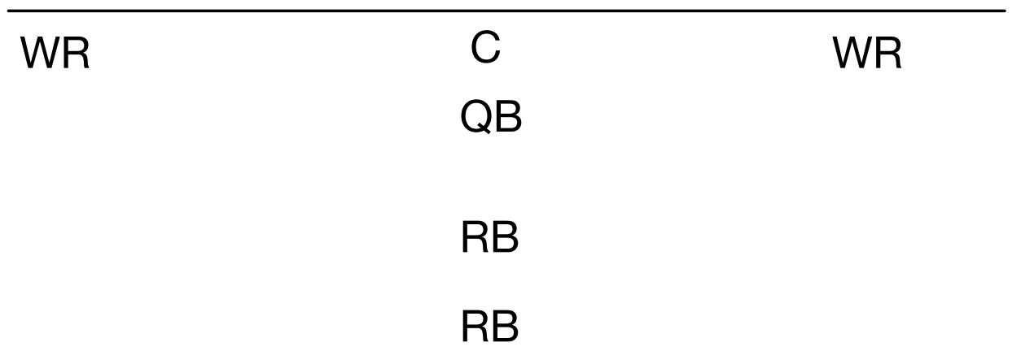

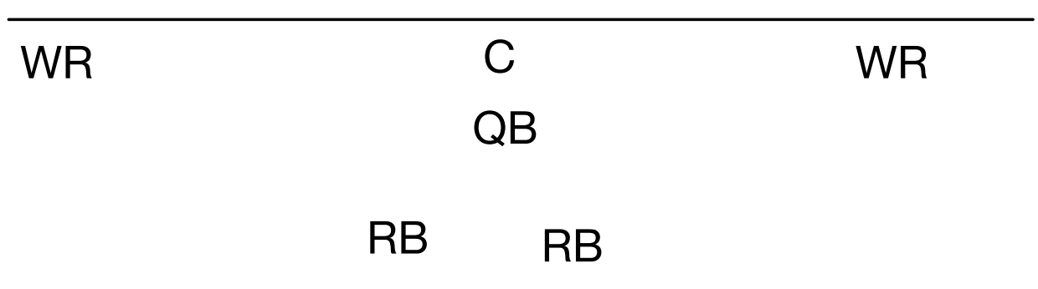

Trick Plays
Trick plays are counter to the mission and purpose of the league and are strictly forbidden in Maroon league. They are defined as any play designed to intentionally misdirect the defensive player on the direction of the play, using deception and/or unorthodox play-calling. Common trick plays include:
- Play action pass / fake handoff
- Pump fake
- Halfback pass/option
- Wide receiver pass/fake reverse
- Reverse
- Motion, bunch or other unorthodox formations
- Counter plays
- Draw plays
Trick plays will result in loss of down. Multiple infractions may be deemed Unsportsmanlike Conduct by the referee. “Jet sweeps” (where WR receives a toss from the QB are allowed. The WR must catch the ball beyond the nose guard cone, and it must be a toss from the QB. If the ball hits the ground, it is an incomplete pass.

QB Play
The QB may handoff, pitch or pass from anywhere in the backfield. However, he/she may not run forward for yardage or interact in the play after the ball leaves their hand. Teams must utilize multiple quarterbacks each game. When the coach is the QB, a pass cannot cross 2 lines in the air. If the ball is on the 20-yard line, the pass cannot cross midfield in the air. If the ball is short of midfield, it cannot cross the opposite 20. If the ball is past midfield, the pass cannot cross the goal line in air.
Possession Count
There is a 7 “Mississippi” count before which the QB must be rid of the football either by passing or handing off. Referees will make the count out loud and will blow the play dead accordingly. The ball will be placed back at the line of scrimmage with a loss of down.
Fumbles
A fumbled snap or a fumbled backfield exchange will result in a dead ball and a replay of the down.
Defensive Alignment
All defensive alignments must play “man coverage”. Nose guard is 3 yards off the line of scrimmage. Cornerbacks and Linebackers can be between 3-5 yards off the line of scrimmage. “Crowding” the line of scrimmage is not allowed. Crowding is defined as moving linebackers forward to the LOS. There is no safety allowed.
Defensive Rushing/Rushing the QB
Players may cross the line of scrimmage to “rush” the backfield only in the following conditions:
- Once the ball is handed off to a ball carrier
- If a pass is thrown behind the line of scrimmage
Otherwise, all athletes play man to man and or defend the line of scrimmage accordingly. There is no blitzing nor rushing a passing QB.
Tackles for Losses
There are no negative plays in the Maroon league. If a tackle is made behind the line of scrimmage, the ball is placed at the original line of scrimmage.
Interceptions
Interceptions will be declared dead ball at the spot of the interception and cannot be advanced.
Inside the 5
When the ball is downed on the five or inside the five-yard line, forward pass plays only will be allowed. No screen passes. The offense cannot rush the ball, unless the defense rushes the QB.

